

**Polytechnic University of Puerto Rico**

**Department of Computer Engineering and Computer Science**

**COE 4002-39: Capstone I / CS 4002-49: Computer Science Project I**

**WI-20 / Prof. Othoniel Rodriguez**

**Covid-19 Data Visualization & Analysis:**

Software Requirements Specifications (SRS)

|  |  |  |
| --- | --- | --- |
| Name | ID | Program |
| Jose M. Lopez Torres | #72583 | CS |
| Elias J. Marrero Ruiz | #97850 | CS |
| Ernesto Feliciano Muniz | #96861 | COE |
| Diego Canals Reyes | #80877 | COE |

# Table of Contents

Table of Contents 2

Table of Figures 7

Introduction 8

User Stories 9

Table 1: User Stories and Priority Levels 9

Client Role Involvement 10

Detailed User Stories 10

1.1 User Story 10

1.2 User Acceptance Test 10

1.3 User Story Workflow 11

Figure 1. Workflow for Plot’s Zoom 11

1.4 Data Requirements 11

1.5 Wireframe Template 11

Figure 2. Wireframe of Plot Zoom 11

2.1 User Story 12

2.2 User Acceptance Test 12

2.3 User Story Workflow 13

Figure 3. Workflow of Error Report 13

2.4 Data Requirements 13

2.5 Wireframe Template 13

Figure 4. Workflow of Error Report 13

3.1 User Story 14

3.2 User Acceptance Test 14

3.3 User Story Workflow 14

Figure 5. Workflow of Data References 14

3.4 Data Requirements 14

3.5 Wireframe Template 14

Figure 6. Wireframe of Data References 14

4.1 User Story 15

4.2 User Acceptance Test 15

4.3 User Story Workflow 15

Figure 7. Workflow of Comparative Ages 15

4.4 Data Requirements 15

4.5 Wireframe Template 15

Figure 8. Wireframe of Comparative Ages 15

5.1 User Story 16

5.2 User Acceptance Test 16

5.3 User Story Workflow 16

Figure 9. Workflow of Age Ranges 16

5.4 Data Requirements 16

5.5 Wireframe Template 16

Figure 10. Workflow of Age Ranges 16

6.1 User Story 17

6.2 User Acceptance Test 17

6.3 User Story Workflow 17

Figure 11. Workflow of Colorblind Options 17

6.4 Data Requirements 18

6.5 Wireframe Template 18

Figure 12. Wireframe of Colorblind Options 18

7.1 User Story 18

7.2 User Acceptance Test 18

7.3 User Story Workflow 18

Figure 13. Workflow of Sharing Graphics 18

7.4 Data Requirements 19

7.5 Wireframe Template 19

Figure 14. Wireframe of Sharing Graphics 19

8.1 User Story 19

8.2 User Acceptance Test 19

8.3 User Story Workflow 20

Figure 15. Workflow of Viewing the Vaccinated People’s Graphic 20

8.4 Data Requirements 20

8.5 Wireframe Template 20

Figure 16. Wireframe of Viewing the Vaccinated People’s Graphic 20

9.1 User Story 20

9.2 User Acceptance Test 20

9.3 User Story Workflow 21

Figure 17. Workflow of Changing a Graphic 21

9.4 Data Requirements 21

9.5 Wireframe Template 21

Figure 18. Wireframe of the Changing of a Graphic 21

10.1 User Story 22

10.2 User Acceptance Test 22

10.3 User Story Workflow 22

Figure 19. Workflow of Finding Data Updates Label 22

10.4 Data Requirements 22

10.5 Wireframe Template 22

Figure 20. Wireframe of Finding Data Updates Label 22

11.1 User Story 22

11.2 User Acceptance Test 22

11.3 User Story Workflow 24

Figure 21. Workflow of Daily Summaries 24

11.4 Data Requirements 24

11.5 Wireframe Template 24

Figure 22. Workflow of Daily Summaries 24

12.1 User Story 25

12.2 User Acceptance Test 25

12.3 User Story Workflow 25

Figure 23. Workflow of Summaries 25

12.4 Data Requirements 26

12.5 Wireframe Template 26

Figure 24. Wireframe of Summaries 26

13.1 User Story 26

13.2 User Acceptance Test 26

13.3 User Story Workflow 27

Figure 25. Workflow of Municipality Hospitalizations 27

13.4 Data Requirements 27

13.5 Wireframe Template 27

Figure 26. Wireframe of Municipality Hospitalizations 27

14.1 User Story 28

14.2 User Acceptance Test 28

14.3 User Story Workflow 28

Figure 27. Workflow of Municipality Testing 28

14.4 Data Requirements 28

14.5 Wireframe Template 28

Figure 28. Workflow of Municipality Testing 28

15.1 User Story 29

15.2 User Acceptance Test 29

15.3 User Story Workflow 29

Figure 29. Workflow of Pie Chart Change 29

15.4 Data Requirements 29

15.5 Wireframe Template 29

Figure 30. Wireframe of Pie Chart Change 29

16.1 User Story 30

16.2 User Acceptance Test 30

16.3 User Story Workflow 30

Figure 31. Workflow of Download/Embed Graph 30

16.4 Data Requirements 30

16.5 Wireframe Template 31

Figure 32. Wireframe of Download/Embed Graph 31

17.1 User Story 31

17.2 User Acceptance Test 31

17.3 User Story Workflow 31

17.4 Data Requirements 32

17.5 Wireframe Template 32

Figure 34. Workflow of Graphic Hover Box 32

18.1 User Story 32

18.2 User Acceptance Test 32

18.3 User Story Workflow 32

Figure 35. Workflow of Graph Time Period Selection 32

18.4 Data Requirements 32

18.5 Wireframe Template 33

Figure 36. Wireframe of Graph Time Period Selection 33

19.1 User Story 33

19.2 User Acceptance Test 33

19.3 User Story Workflow 34

Figure 37. Workflow of Graph Age Range Selection 34

19.4 Data Requirements 34

19.5 Wireframe Template 34

Figure 38. Wireframe of Graph Age Range Selection 34

20.1 User Story 34

20.2 User Acceptance Test 34

Figure 39. Workflow of Graph Time Period Selection 34

20.5 Wireframe Template 35

Figure 40. Wireframe of Graph Time Period Selection 35

Maintainability/Evolvability 36

Reliability 36

Availability 36

Usability 36

Scalability 37

Hosting Costs Per Year 37

Portability 37

# Table of Figures

Figure 1. Workflow for Plot’s Zoom 11

Figure 2. Wireframe of Plot Zoom 11

Figure 3. Workflow of Error Report 13

Figure 4. Workflow of Error Report 13

Figure 5. Workflow of Data References 14

Figure 6. Wireframe of Data References 14

Figure 7. Workflow of Comparative Ages 15

Figure 8. Wireframe of Comparative Ages 15

Figure 9. Workflow of Age Ranges 16

Figure 10. Workflow of Age Ranges 16

Figure 11. Workflow of Colorblind Options 17

Figure 12. Wireframe of Colorblind Options 18

Figure 13. Workflow of Sharing Graphics 18

Figure 14. Wireframe of Sharing Graphics 19

Figure 15. Workflow of Viewing the Vaccinated People’s Graphic 20

Figure 16. Wireframe of Viewing the Vaccinated People’s Graphic 20

Figure 17. Workflow of Changing a Graphic 21

Figure 18. Wireframe of the Changing of a Graphic 21

Figure 19. Workflow of Finding Data Updates Label 22

Figure 20. Wireframe of Finding Data Updates Label 22

Figure 21. Workflow of Daily Summaries 24

Figure 22. Workflow of Daily Summaries 24

Figure 23. Workflow of Summaries 25

Figure 24. Wireframe of Summaries 26

Figure 25. Workflow of Municipality Hospitalizations 27

Figure 26. Wireframe of Municipality Hospitalizations 27

Figure 27. Workflow of Municipality Testing 28

Figure 28. Workflow of Municipality Testing 28

Figure 29. Workflow of Pie Chart Change 29

Figure 30. Wireframe of Pie Chart Change 29

Figure 31. Workflow of Download/Embed Graph 30

Figure 32. Wireframe of Download/Embed Graph 31

Figure 34. Workflow of Graphic Hover Box 32

Figure 35. Workflow of Graph Time Period Selection 32

Figure 36. Wireframe of Graph Time Period Selection 33

Figure 37. Workflow of Graph Age Range Selection 34

Figure 38. Wireframe of Graph Age Range Selection 34

Figure 39. Workflow of Graph Time Period Selection 34

Figure 40. Wireframe of Graph Time Period Selection 35

# Introduction

In the following parts we will list every of our user stories with the member that will be working/implementing it. Then we will discuss the Client Role in Involvement with the project, which is substantial and very important for the end product. After this, the detailed user stories come up, which are a more complete version of each story, not only talking about the user acceptance tests (scenarios), but also about its workflow, data requirements and wireframe, to really get an idea of how each one will be implemented. And finally, a series of non-functional requirements that will specify some other details.

# User Stories

The following table presents the user stories that denote the functions of the application.

## Table 1: User Stories and Priority Levels

|  |  |
| --- | --- |
| Team Member | User Story |
| Ernesto | As a user I want to view a summary of daily cases, tests per day, deaths by day and hospitalizations so that I can review the data |
| Ernesto | As a user I want to view graphically a summary of the deaths, cases, and vaccinated people so that I can review the data |
| Ernesto | As a user I want to search municipality testing data for a time period so that I can review the data |
| Ernesto | As a user I want to search municipality hospitalization data for a time period so that I can review the data |
| Ernesto | As a user I want to change the selected graphic from xy scattered to a pie chart so that it can be visualized differently |
| Jose | As a user I want to change the zoom of a graphic so that a specific part can be seen more clearly |
| Jose | As a user I want to view a comparative graphic by age ranges and the total positive cases by age group |
| Jose | As a user I want to view a comparative graphic by age ranges and the total deaths by age group |
| Jose | As a user I want to report an error in the system so that it can be fixed |
| Jose | As a user I want to verify the references of the data showed so that I can also verify it |
| Elias | As a user I want to enable a colorblind mode through a button of a graphic so that I can see different colors on the graph |
| Elias | As a user I want to share the current state of a graphic so that I can notify friends and family |
| Elias | As a user I want to view total vaccinated people by a time period so that I can review the data |
| Elias | As a user I want to change the current graphic through a button so that I can view a different graph |
| Elias | As a user I want to know how frequently the graphics are being updated so that I know how accurate the data is currently |
| Diego | As a user I want to search total deaths for a time period so that I can review the data |
| Diego | As a user I want to search total cases for a time period so that I can review the data |
| Diego | As a user I want to view different age ranges of the cases in a plot so that it can be visualized the data better |
| Diego | As a user I want to hover over a graphic so that I can see a specific data point |
| Diego | As auser I want to be able to download/embed a given graphic to another website so that I can share the data |

# Client Role Involvement

* The client, Danilo Pérez, has provided valuable information that will be vital to this project. He worked with the team as a source of knowledge in this area, also gave a list of APIs and a small sample code on how to make the call and how to manage it. Later on, he also communicated us with Elvis Nieves, the Principal Developer of Bioportal. Elvis Nieves, mentioned which endpoints are available and pending to add, like for example the vaccine data. With all this information available the user stories where created based on the available data of the APIs.

# Detailed User Stories

* The following section will present detailed information regarding the user stories available at Table 1. Also, will provide a handmade drawing of each user story with the respective user scenario.

## User Story

* As a user I want to change the zoom of a graphic so that a specific part can be seen more clearly

## User Acceptance Test

* **Scenario:** I want to increase the zoom of the graph

**Given** I am at the graph

**When** I go to the bottom right of the graph and click the magnifying glass

**And** Click the plus sign to increase the zoom

**Then** The graph’s zoom will increase

* **Scenario:** I want to decrease the zoom of the graph

**Given** I am at the graph

**When** I go to bottom right of the graph and click the magnifying glass

**And** Click the minus sign to decrease the zoom

**Then** The graph’s zoom will decrease

## User Story Workflow

### Figure 1. Workflow for Plot’s Zoom

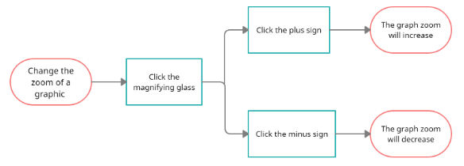

## Data Requirements

* + A frame for the graphic to be plotted in.
  + The desired graphic’s data calculated in the background.
  + The desired plotted graphic, to change its zoom.
  + A button to change the zoom of a graphic, located at the bottom right of the graphic.
  + Two new buttons that will pop up for two actions, the actions will be increase and decrease the zoom.
  + Variables that will hold the zoom percentage.
  + The variables will be validated to control the input value from being out of the parameters accepted for that variable.

## Wireframe Template

### Figure 2. Wireframe of Plot Zoom

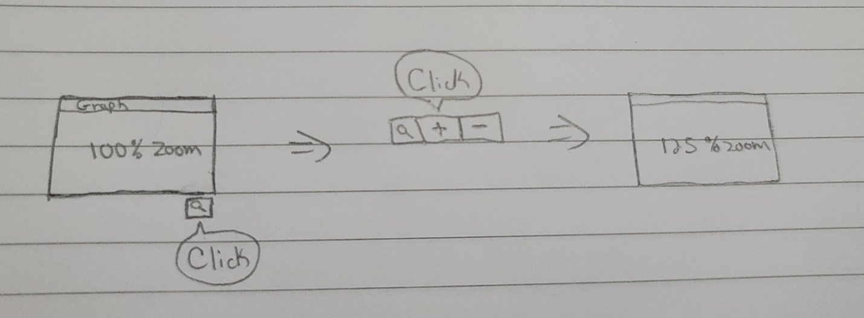

## User Story

* + As a user I want to report an error in the webpage so that it can be fixed

## User Acceptance Test

* **Scenario:** I want to report an error of a graph

**Given** I am at the top of the page

**When** I go to the bottom page

**And** Click the report button  
**And** Click the dropdown button

**Then** Select the error of a graph report  
**And** Describe the error in the text box  
**And** Click the report button

* **Scenario:** I want to report an error of the data of a graph

**Given** I am at the top of the page

**When** I go to the bottom page

**And** Click the report button  
**And** Click the dropdown button

**Then** Select the error of the data of a graph report  
**And** Describe the error in the text box  
**And** Click the report button

* **Scenario:** I want to report a specific error

**Given** I am at the top of the page

**When** I go to the bottom page

**And** Click the report button  
**And** Click the dropdown button

**Then** Select the other error report  
**And** Describe the error in the text box  
**And** Click the report button

## User Story Workflow

### Figure 3. Workflow of Error Report

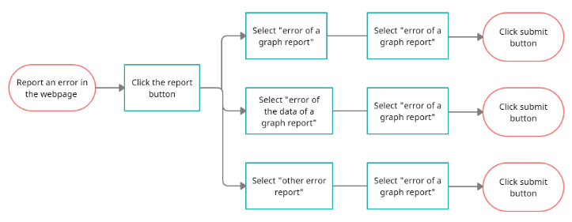

## Data Requirements

* + A report hyperlink to pop up the report form.
  + A dropdown button with three options. These will be error of a graph report, error of the data of a graph report and other error report.
  + A textbox so the user can describe the error.
  + A button so the user can submit the report.
  + A variable that will hold the strings of the text box.
  + This variable will be validated before the database to confirm that is receiving the values of the expected format.

## Wireframe Template

### Figure 4. Workflow of Error Report

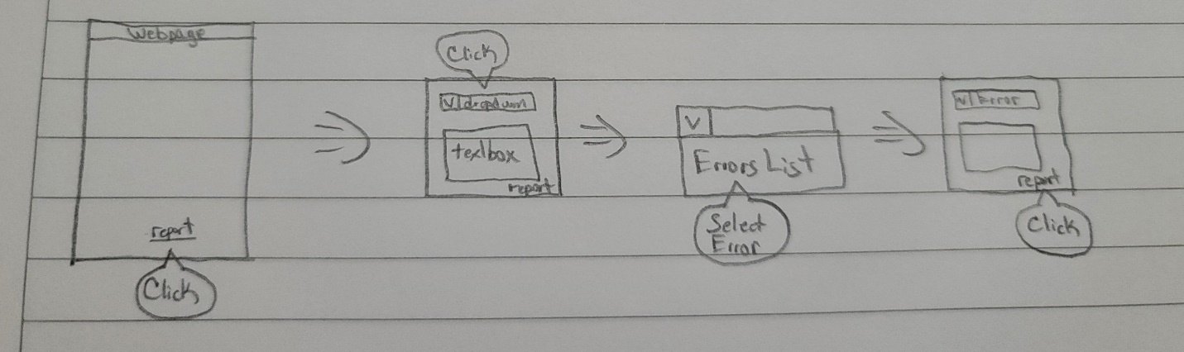

## User Story

* + As a user I want to verify the references of the data showed so that I can review it

## User Acceptance Test

* **Scenario:** I want to see the references

**Given** I am at the top of the page

**When** I go to the bottom page

**Then** Click the reference button

## User Story Workflow

### Figure 5. Workflow of Data References

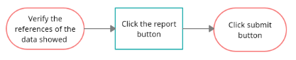

## Data Requirements

* + A reference hyperlink to pop up the reference form.
  + A form showing the references of the data.
  + Variables are not required in this case since the user will just click a hyperlink.

## Wireframe Template

### Figure 6. Wireframe of Data References

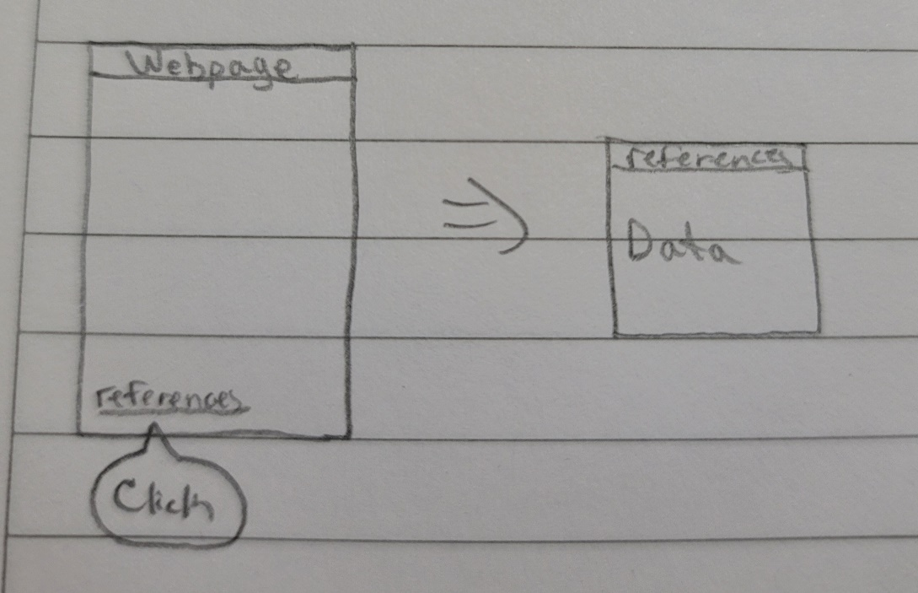

## User Story

* + As a user I want to view a comparative graphic by age ranges and the total positive cases by age group

## User Acceptance Test

* **Scenario:** I want to view a comparative graphic by age ranges and the total positive cases by age group

**Given** I am at the Exchangeable Graphic’s dropdown

**When** I click the dropdown

**And** I look for the comparative graphic

**Then** I will choose the graph by age range by positive cases  
**And** I will be able to see/interact with it

## User Story Workflow

### Figure 7. Workflow of Comparative Ages

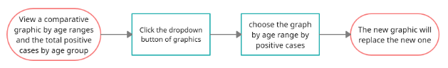

## Data Requirements

* + A dropdown that will hold the list to all the graphics available.
  + A frame for the graphic to be plotted in.
  + The desired graphic’s data calculated in the background.
  + The data of total positive case by age to show in the graph.
  + **Data Validation**: Not Required. The data required for each graph will be already validated and ready to be called from the database, and the dropdown only shows a list of the graphics.

## Wireframe Template

### Figure 8. Wireframe of Comparative Ages

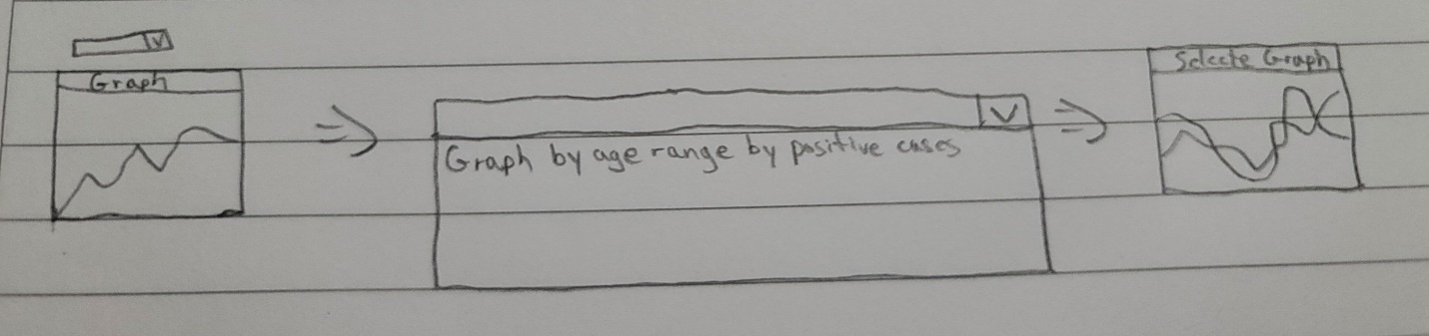

## User Story

* + As a user I want to view a comparative graphic by age ranges and the total deaths by age group

## User Acceptance Test

* **Scenario:** I want to view a comparative graphic by age ranges and the total deaths by age group

**Given** I am at the Exchangeable Graphic’s dropdown

**When** I click the dropdown

**And** I look for the comparative graphic

**Then** I will choose the graph by age range by total deaths  
**And** I will be able to see/interact with it

## User Story Workflow

### Figure 9. Workflow of Age Ranges

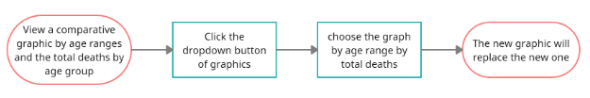

## Data Requirements

* + A dropdown that will hold the list to all the graphics available.
  + A frame for the graphic to be plotted in.
  + The desired graphic’s data calculated in the background.
  + The data of total deaths by age to show in the graph.
  + **Data Validation**: Not Required. The data required for each graph will be already validated and ready to be called from the database, and the dropdown only shows a list of the graphics.

## Wireframe Template

### Figure 10. Workflow of Age Ranges

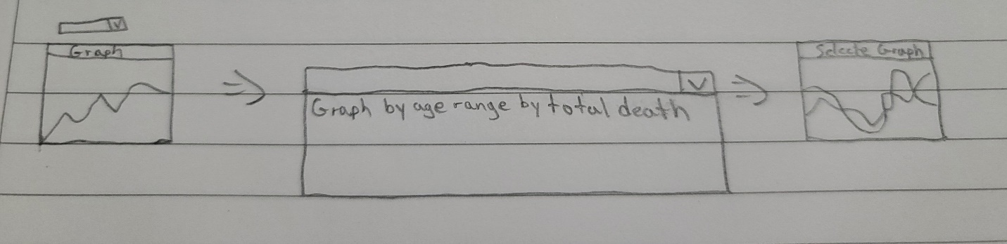



## User Story

* As a user I want to enable a colorblind mode through a button of a graphic so that I can see different colors on the graph

## User Acceptance Test

* **Scenario:**  I want to access the colorblind options

**Given** I am at the graphic that I want to see differently

**When** I go to the top right where I can choose the settings for colorblindness

**And** I click the label that specifies “deuteranopia”

**Then** the graphic will change

**And** I will see the same graphic but with different colors

* **Scenario:**  I want to access the colorblind options

**Given** I am at the graphic that I want to see differently

**When** I go to the top right where I can choose the settings for colorblindness

**And** I click the label that specifies “tritanopia”

**Then** the graphic will change

**And** I will see the same graphic but with different colors

* **Scenario:**  I want to access the colorblind options

**Given** I am at the graphic that I want to see differently

**When** I go to the top right where I can choose the settings for colorblindness

**And** I click the label that specifies “protanopia”

**Then** the graphic will change

**And** I will see the same graphic but with different colors

## User Story Workflow

### Figure 11. Workflow of Colorblind Options

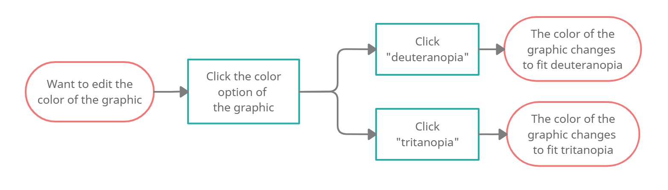

## Data Requirements

* + A frame for the graphic to be plotted in.
  + The desired graphic’s data calculated in the background.
  + The desired plotted graphic, to change its colors.
  + A button to change the color of a graphic, located at the top right of the graphic.
  + A dropdown that will have 3 label/buttons, this will be “deuteranopia”, “tritanopia” and “protanopia”.
  + Variables that will hold the colors of the graphic.
  + **Data Validation**: When the user chooses the disability, the colors must change, so we will validate the new variables of colors for the graphs, to avoid an error in the colors.

## Wireframe Template

### Figure 12. Wireframe of Colorblind Options

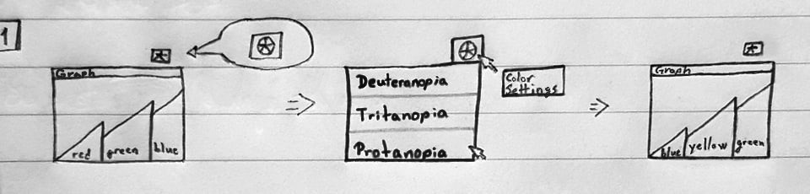

## User Story

* + As a user I want to share the current state of a graphic so that I can notify other people

## User Acceptance Test

* **Scenario:** I want to share a graphic

**Given** I am at the graphic that I want to share

**When** I go to the top right where there is a twisted arrow

**And** I click the arrow

**Then** I will be able to copy a link to share

## User Story Workflow

### Figure 13. Workflow of Sharing Graphics

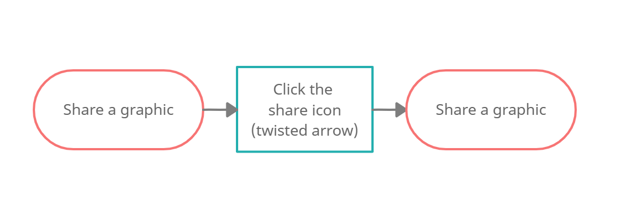

## Data Requirements

* + A button to share the graphic, located at the top right of the graphic, besides the change color button.
  + A function that will generate the link, to share the graphic on the website, when the user clicks the share button.
  + The option to copy the link will appear as in a popup frame.
  + **Data Validation**: Not Required. The page will automate the generation of a link.

## Wireframe Template

### Figure 14. Wireframe of Sharing Graphics

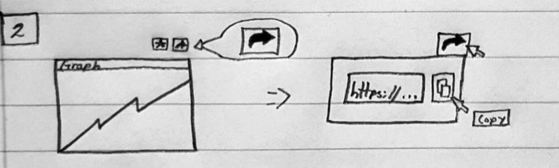

## User Story

* + As a user I want to view total vaccinated people by a time period so that I can review the data

## User Acceptance Test

* **Scenario:** I want to see the specific graphic of “total vaccinated people”
  + **Given** I am at the Exchangeable Graphic’s dropdown
  + **When** I click the dropdown
  + **And** I look for the “total vaccinated people” graphic
  + **Then** I will be able to see/interact with it

## User Story Workflow

### Figure 15. Workflow of Viewing the Vaccinated People’s Graphic

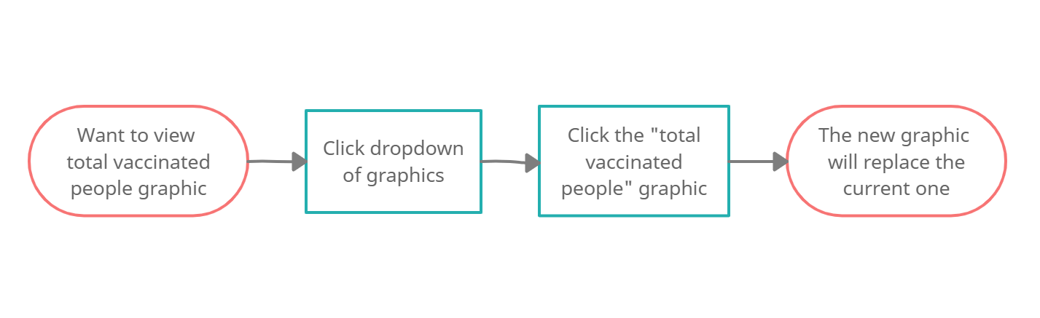

## Data Requirements

* + The dropdown that will hold the list to all the graphics available.
  + A frame for the graphic to be plotted in.
  + The desired graphic’s data calculated in the background.
  + The total vaccinated people by time plotted graphic.
  + **Data Validation**: Not Required. The data for the graphic has already been validated when pulled from the API.

## Wireframe Template

### Figure 16. Wireframe of Viewing the Vaccinated People’s Graphic

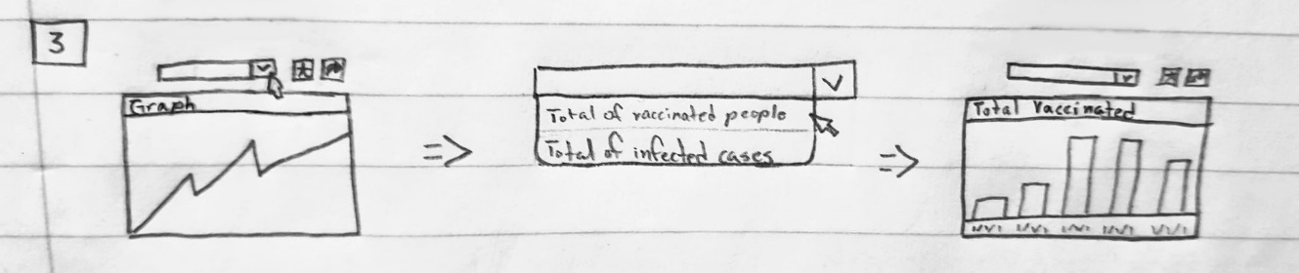

## User Story

* + As a user I want to change the current graphic through a button so that I can view a different graph

## User Acceptance Test

* + **Scenario:** I want to look up a different data graphic

**Given** I am at the exchangeable graphic

**When** I go to the top middle where I can click a dropdown of graphics

**And** I click the desired data to be viewed

**Then** the new graphic will replace the current graphic

**And** I will be able to see/interact with it

* + **Scenario:** I want to look up a different data graphic

**Given** I am at the bottom of the home page

**When** I scroll up and see a dropdown button under a label that says “Exchangeable graphic”

**And** I click the desired data to be viewed

**Then** the new graphic will replace the current graphic

**And** I will be able to see/interact with it

* + **Scenario:** I want to look up a different data graphic

**Given** I am at the top of the home page

**When** I scroll down and see a dropdown button under a label that says “Exchangeable graphic”

**And** I click the desired data to be viewed

**Then** the new graphic will replace the current graphic

**And** I will be able to see/interact with it

## 9.3 User Story Workflow

### Figure 17. Workflow of Changing a Graphic

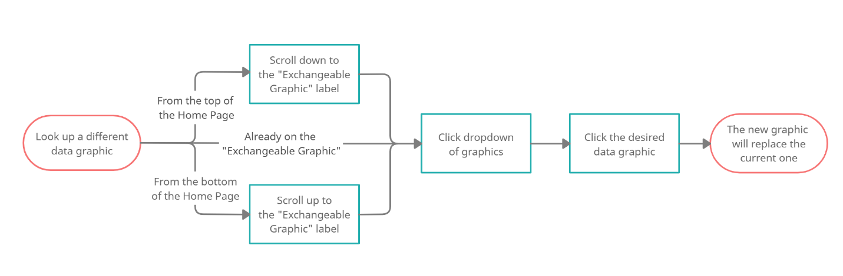

## Data Requirements

* + A label that will say “Exchangeable Graphic” for the user to know where it can see other graphics.
  + The dropdown that will hold the list to all the graphics available.
  + A frame for the graphic to be plotted in.
  + The desired graphic’s data calculated in the background.
  + **Data Validation**: Not Required. The data required for each graph will be already validated and ready to be called from the database, and the dropdown only shows a list of the graphics.

## Wireframe Template

### Figure 18. Wireframe of the Changing of a Graphic

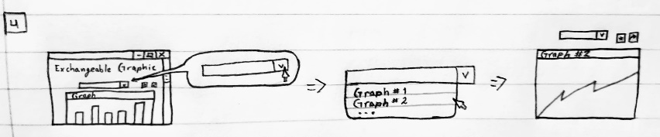

## User Story

* + As a user I want to know how frequently the graphics are being updated so that I know how accurate the data is currently

## User Acceptance Test

* + **Scenario:** I want to know how frequently the graphics are being updated

**Given** I am at the start of the home page

**When** I scroll down to the bottom

**Then** I will see a label that says “Data is updated every ## hours”

## User Story Workflow

### Figure 19. Workflow of Finding Data Updates Label

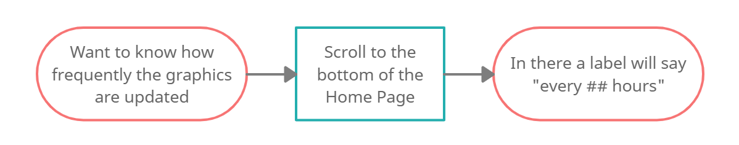

## Data Requirements

* + A label that specifies when the graphics are updated.
  + A variable that holds the value of the time because the time might change.
  + **Data Validation**: Not Required. It’s just a label that the user can read to know how accurate the data is.

## Wireframe Template

### Figure 20. Wireframe of Finding Data Updates Label

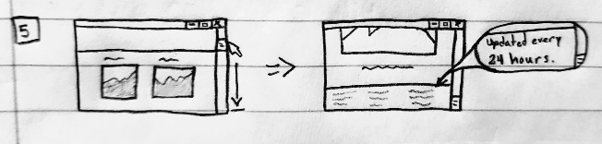

## User Story

* As a user I want to view a summary of daily cases, tests per day, deaths by day and hospitalizations so that I can review the data

## User Acceptance Test

* **Scenario:** I want to view graphically the summary of daily cases

**Given** I am at the drop-down list of Daily Statistics

**When** I go down in the menu where I can choose the summary of daily cases

**And** I click “Summary of Daily Cases”

**Then** I will see a graphic showing the cases of the day

* **Scenario:** I want to view graphically the tests per day

**Given** I am at the drop-down list of Daily Statistics

**When** I go down in the menu where I can choose the tests per day

**And** I click “Daily Tests”

**Then** I will see a graphic showing the tests made in the day

* **Scenario:** I want to view graphically the deaths by day

**Given** I am at the drop-down list of Daily Statistics

**When** I go down in the menu where I can choose the number of deaths

**And** I click “Daily Deaths”

**Then** I will see a graphic showing the deaths that happened in the day

* **Scenario:** I want to view graphically the hospitalizations by day

**Given** I am at the drop-down list of Daily Statistics

**When** I go down in the menu where I can choose the hospitalizations of the day

**And** I click “Daily Hospitalizations”

**Then** I will see a graphic showing the number of hospitalizations of the day

## User Story Workflow

### Figure 21. Workflow of Daily Summaries

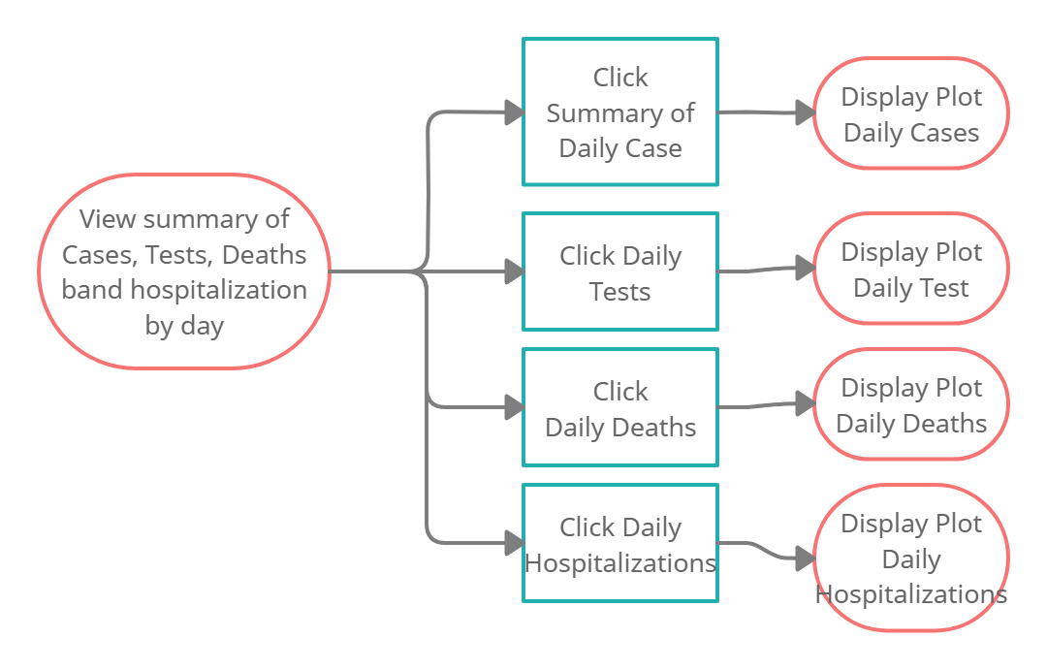

## Data Requirements

* + Available API’s that will retrieve the data from the servers.
  + A drop-down list that will hold the options for selections
  + A window frame for the plots to be displayed
  + A format for each of the plots including the title and a description

## Wireframe Template

### Figure 22. Workflow of Daily Summaries

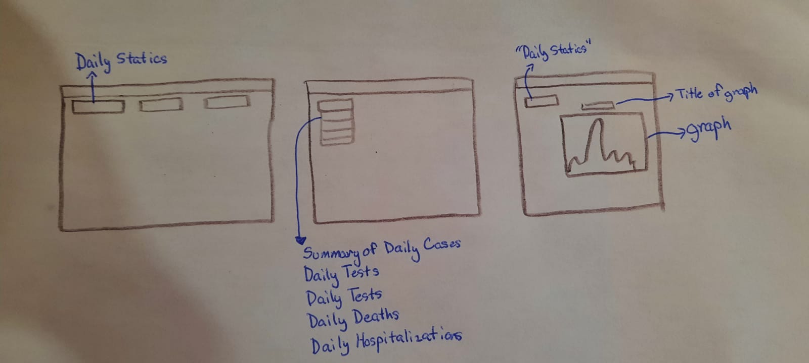

## User Story

* + As a user I want to view graphically a summary of the deaths, cases, and vaccinated people so that I can review the data

## User Acceptance Test



* **Scenario:** I want to view graphically the summary of cases

**Given** I am at the drop-down list of Summaries

**When** I go down in the menu where I can choose summary of the cases

**And** I click “Cases Summary”

**Then** I will see a graphic showing the summary of the cases

* **Scenario:** I want to view graphically the summary of vaccinated people

**Given** I am at the drop-down list of Summaries

**When** I go down in the menu where I can choose summary of the vaccinated people

**And** I click “Vaccinated Summary”

**Then** I will see a graphic showing the summary of the people that are vaccinated

## User Story Workflow

### Figure 23. Workflow of Summaries

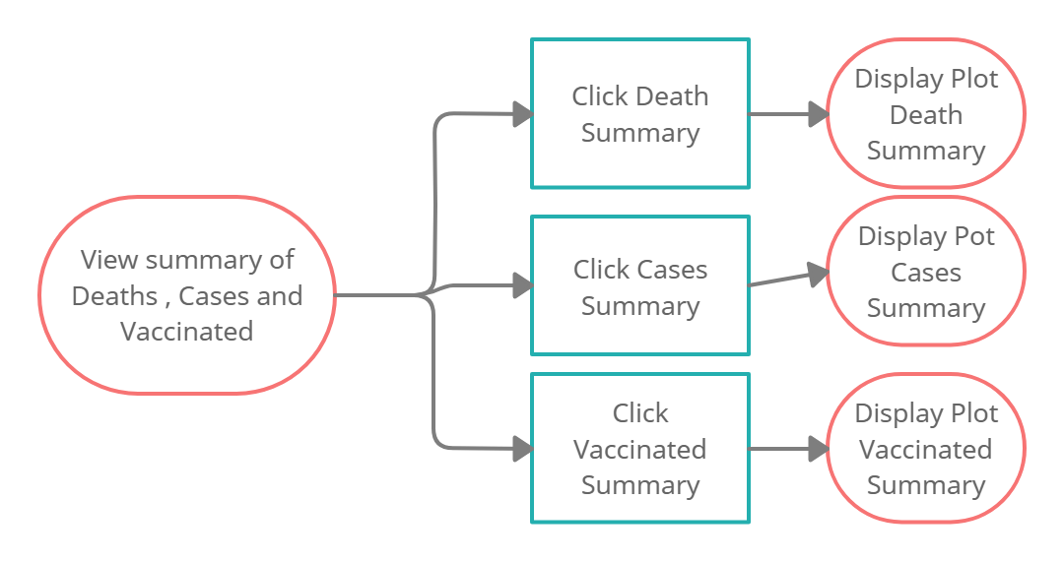

## Data Requirements

* + Available API’s that will retrieve the data from the servers.
  + A drop-down list that will hold the options for selections
  + A window frame for the plots to be displayed
  + A format for each of the plots including the title and a description

## Wireframe Template

### Figure 24. Wireframe of Summaries

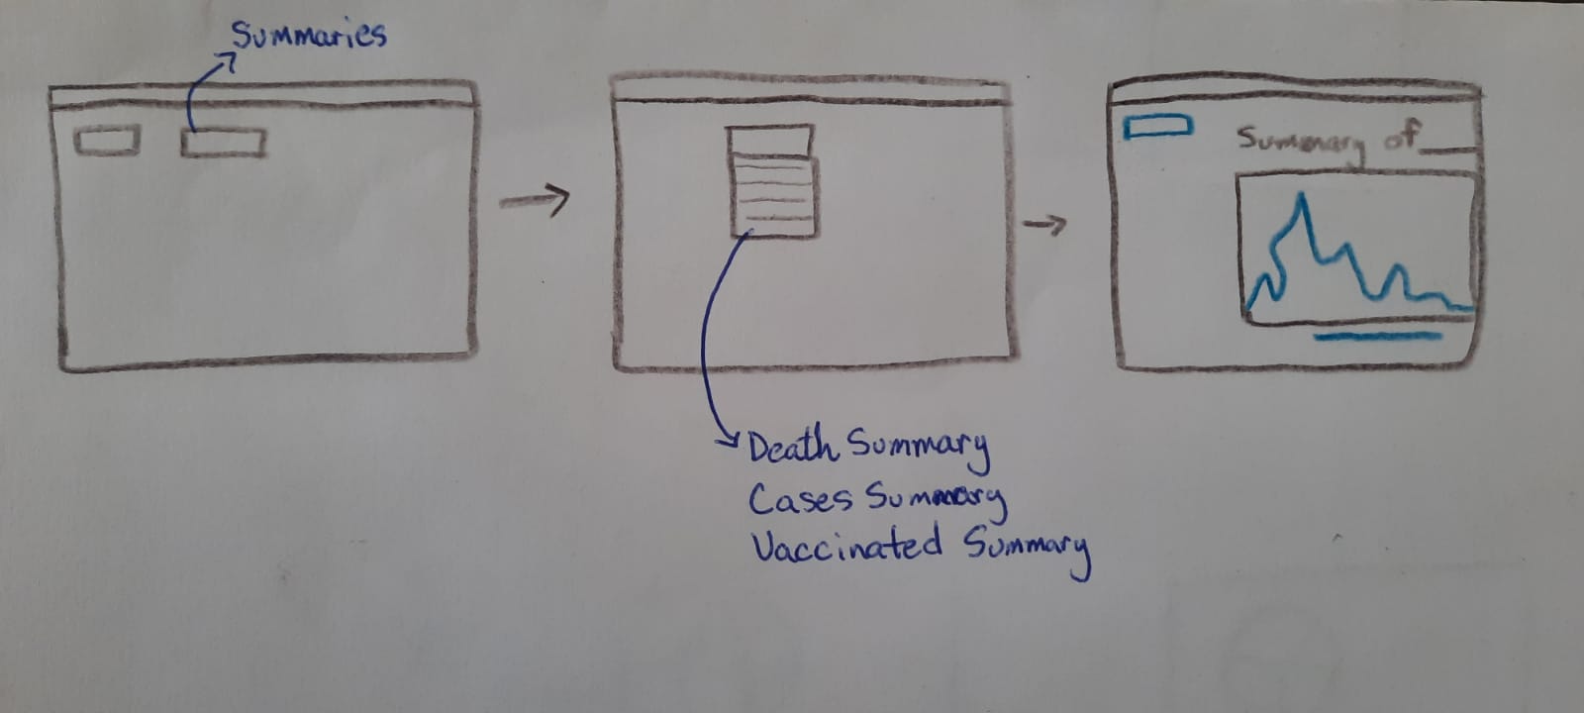

## User Story

* + As a user I want to search municipality hospitalization data for a time period so that I can review the data

## User Acceptance Test

* **Scenario:** I want to search the data of hospitalizations by municipality in a given time

**Given** I am at the graph of hospitalizations and select the municipality and time

**When** I select the municipality and a given date

**And** I click “Name_of_Municipality”

**Then** I will see a graphic of the hospitalizations in the selected municipality

## User Story Workflow

### Figure 25. Workflow of Municipality Hospitalizations

## Data Requirements

* + Available API’s that will retrieve the data from the servers.
  + A button with a drop-down list of all the municipalities of Puerto Rico
  + A button with a calendar for the selection of the period of time
  + A window frame for the plots to be displayed
  + A format for each of the plots including the title and a description

## Wireframe Template

### Figure 26. Wireframe of Municipality Hospitalizations

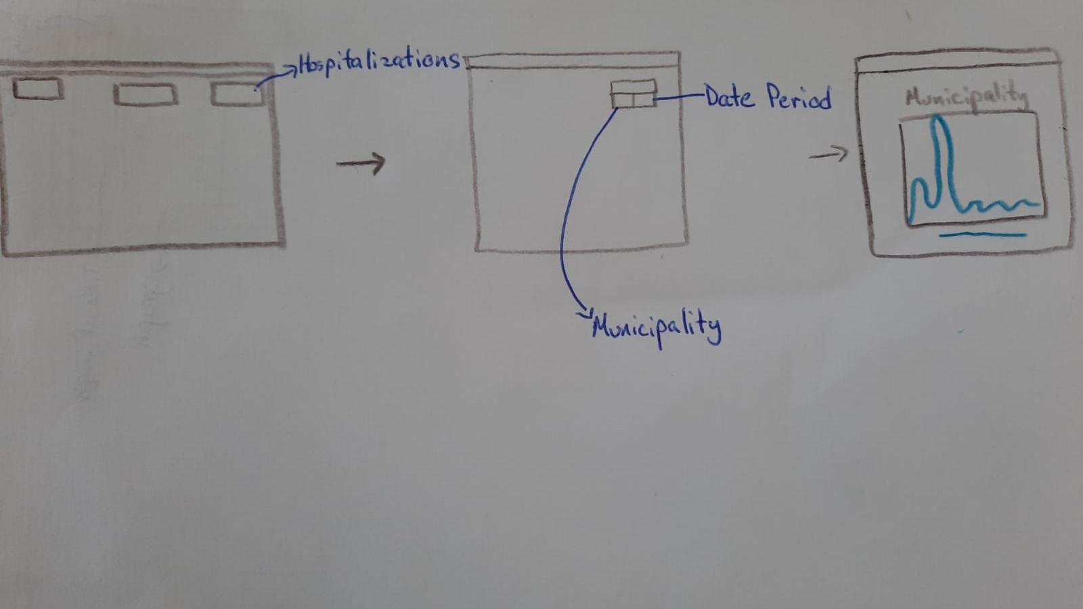

## User Story

* + As a user I want to search municipality testing data for a time period so that I can review the data

## User Acceptance Test

* **Scenario:** I want to search the data of testing by municipality in a period of time

**Given** I am at the graph of tests and select the sort by municipality

**When** I select the municipality testing and a given date

**And** I click “Testing_of_Municipality”

**Then** I will see a graphic of the testing in the selected municipality

## User Story Workflow

### Figure 27. Workflow of Municipality Testing

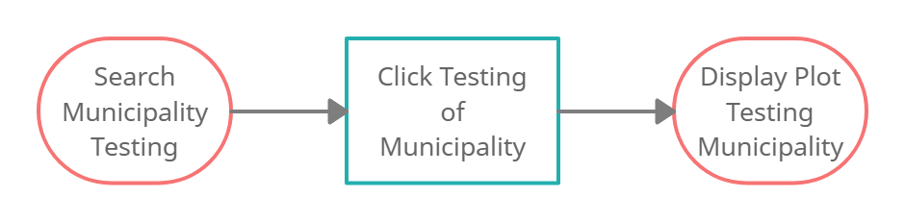

## Data Requirements

* + Available API’s that will retrieve the data from the servers.
  + A button with a drop-down list of all the municipalities of Puerto Rico
  + A window frame for the plot to be displayed
  + A format for each of the plot including the municipality and description

## Wireframe Template

### Figure 28. Workflow of Municipality Testing

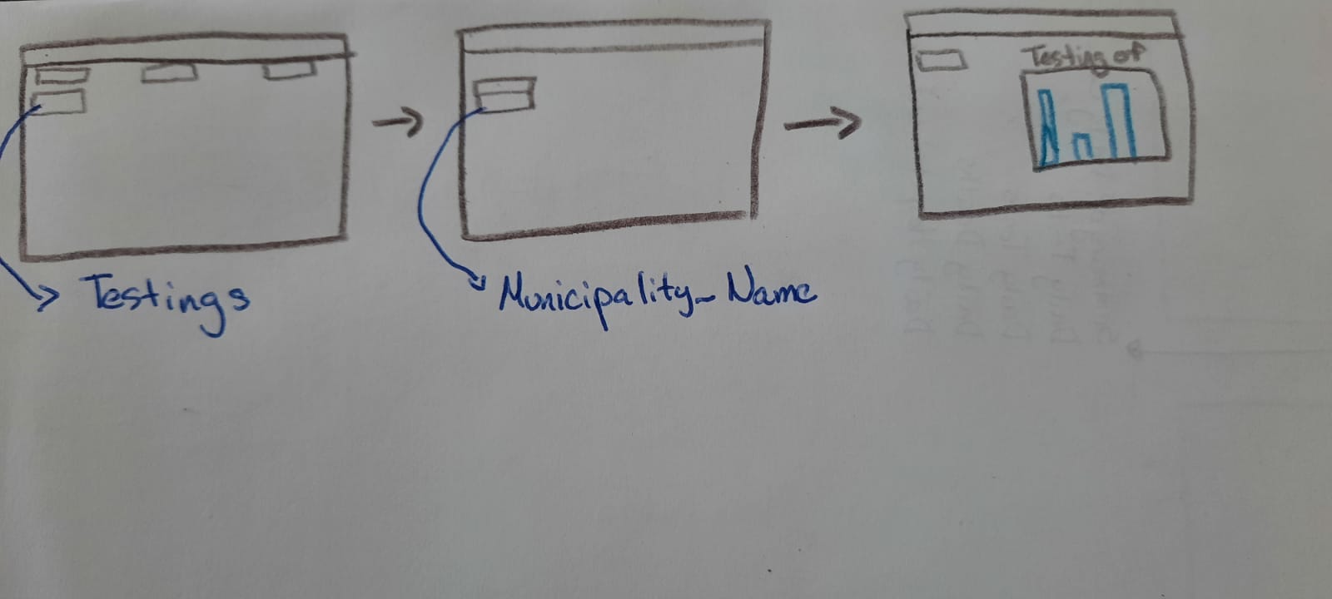

## User Story

* + As a user I want to change the selected graphic from xy scattered to a pie chart so that it can be visualized differently

## User Acceptance Test

* **Scenario:** I want to change any xy scattered plot to their pie chart equivalent plot

**Given** I am at the selected graph and go to the right of the graph

**When** I select the button of the option of pie chart

**And** I click “Pie Chart View”

**Then** I will see a pie chart of the desired graphic

## User Story Workflow

### Figure 29. Workflow of Pie Chart Change

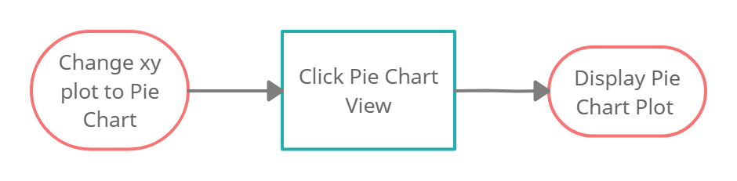

## Data Requirements

* + Available API’s that will retrieve the data from the servers.
  + A button for changing the display view of the plot
  + A converter that changes from xy scattered to pie chart
  + A format for the pie chart and a window frame
  + A button for going back to the original view

## Wireframe Template

### Figure 30. Wireframe of Pie Chart Change

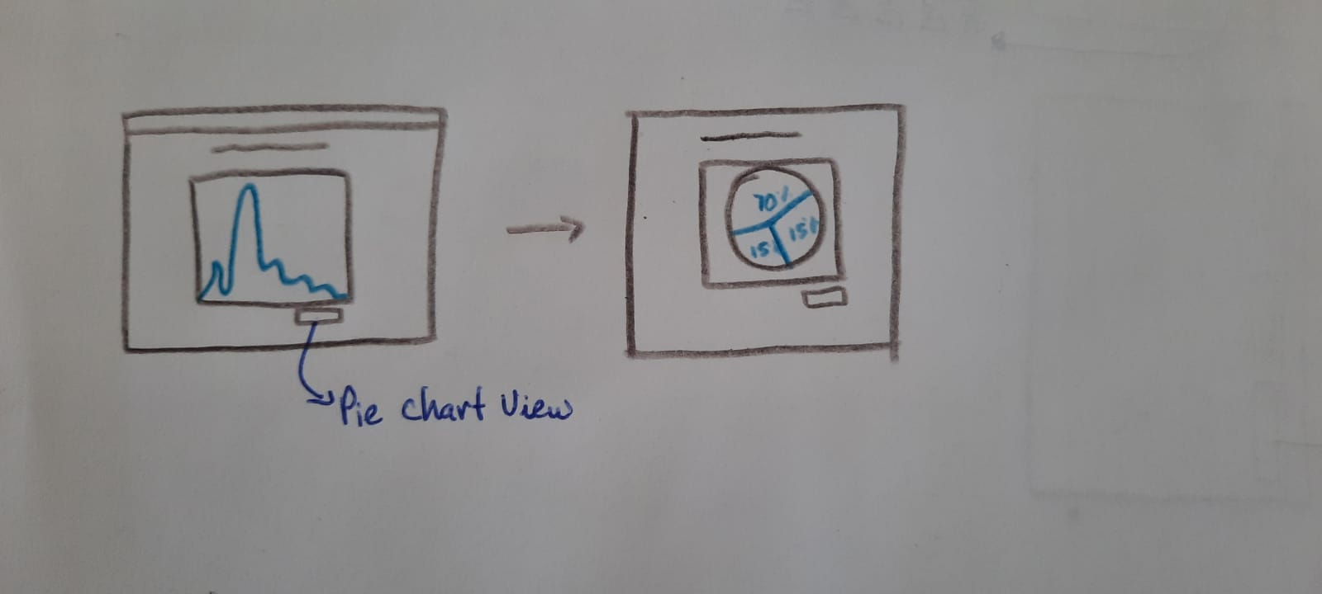

## User Story

* As a user I want to be able to download/embed a given graph to another website to share the data.

## User Acceptance Test

* **Scenario:** I want to download a graph

**Given:** I am at the graph

**When:** I go to the top left of the graph

**And:** Click the download button

**Then:** The graph will be downloaded as an image

* **Scenario:** I want to embed a graph

**Given:** I am at the graph

**When:** I go to the top left of the graph

**And:** Click the embed button

**Then:** The graph will be downloaded as an image

## User Story Workflow

### Figure 31. Workflow of Download/Embed Graph

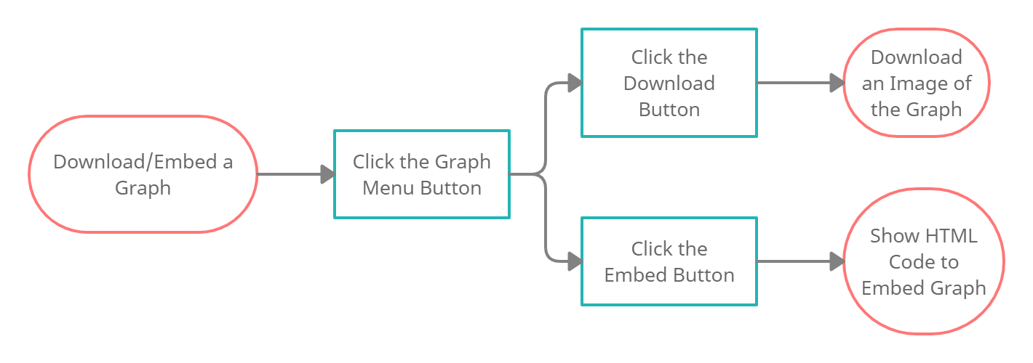

## Data Requirements

* A graph with the desired data.
* A menu on the graph with the options of "Download" and "Embed".

## Wireframe Template

### Figure 32. Wireframe of Download/Embed Graph

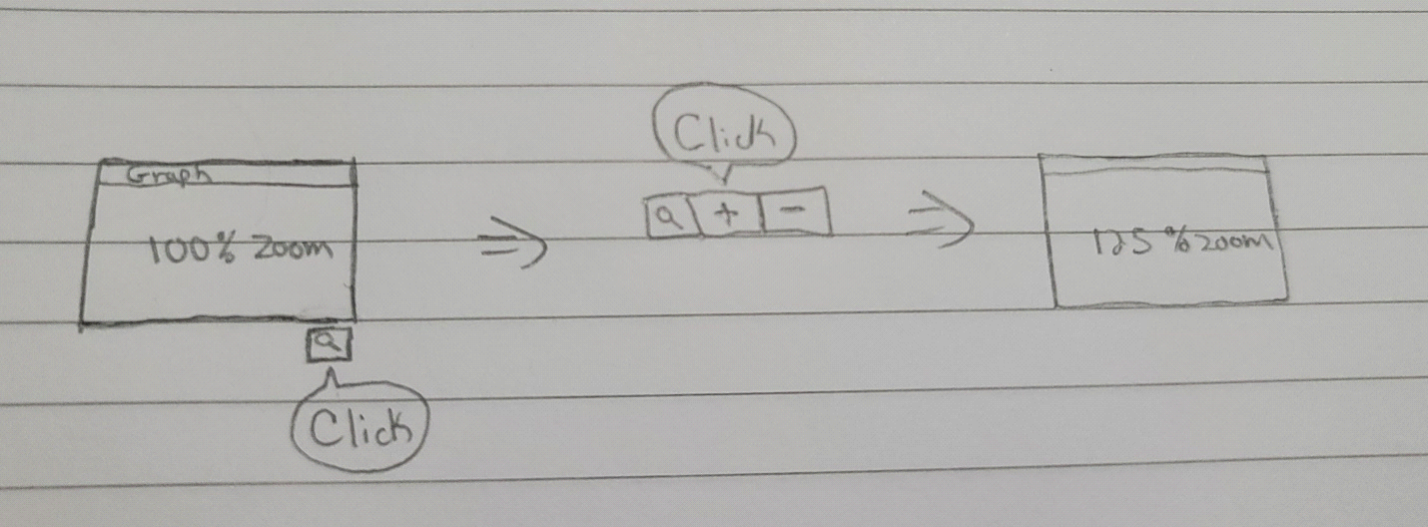

## User Story

* As a user I want to hover above a graphic and highlight a specific data point on the timeline to see data for that particular sample.

## User Acceptance Test

* **Scenario:** I want to view data for a specific time point on the graph.

**Given:** I am on the desired graph.

**When:** I hover with the mouse pointer over the graph.

**Then:** The graph presents a hover box with the relevant time data.

## User Story Workflow

Figure 33. Workflow of Graphic Hover Box

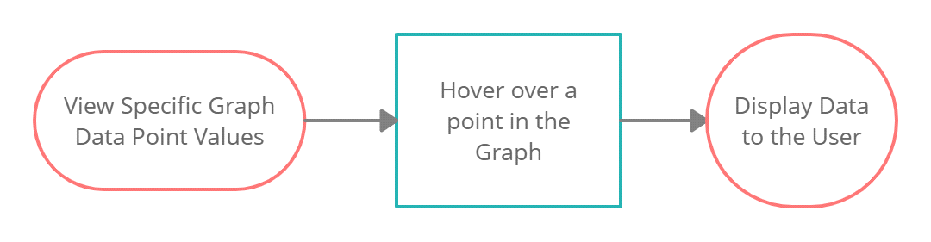

## Data Requirements

* A graph with the desired data.
* Individual data points plotted on the graph each with a hover element.

## Wireframe Template

### Figure 34. Workflow of Graphic Hover Box

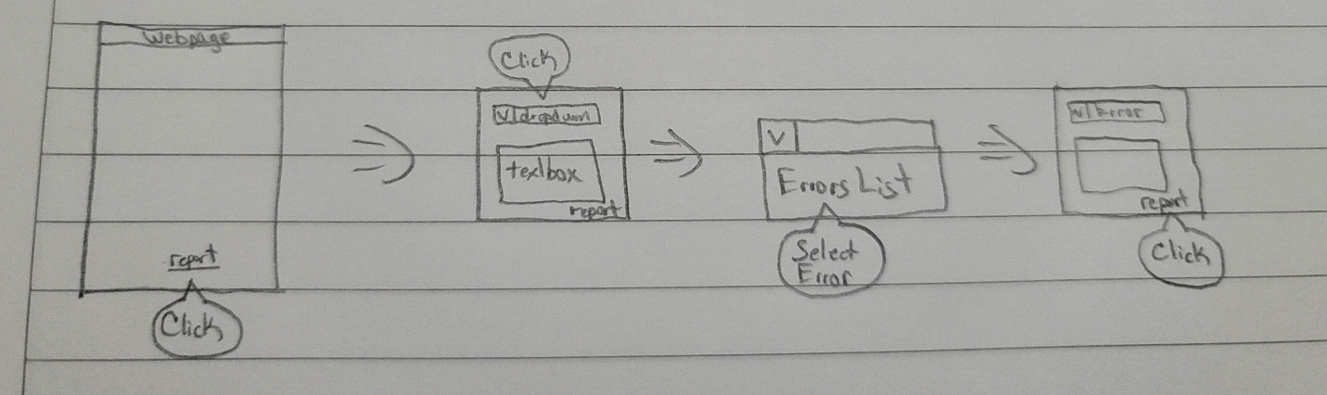

## User Story

* As a user I want to search total deaths for a time period so that I can review the data.

## User Acceptance Test

* **Scenario:** I want to view total deaths for a given time period.

**Given**: I am on a graph that allows time period selection.

**When**: I go to the menu on the graph with the time period options.

**Then**: Click on an option.

## User Story Workflow

### Figure 35. Workflow of Graph Time Period Selection

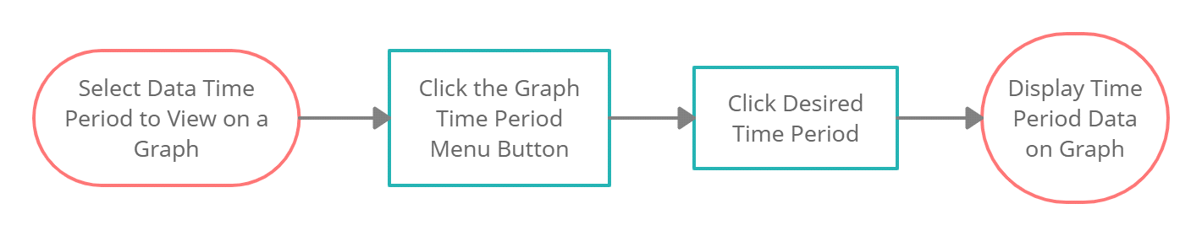

## Data Requirements

* A graph with the desired data that has time selection options.
* A menu with the time options.

## Wireframe Template

### Figure 36. Wireframe of Graph Time Period Selection

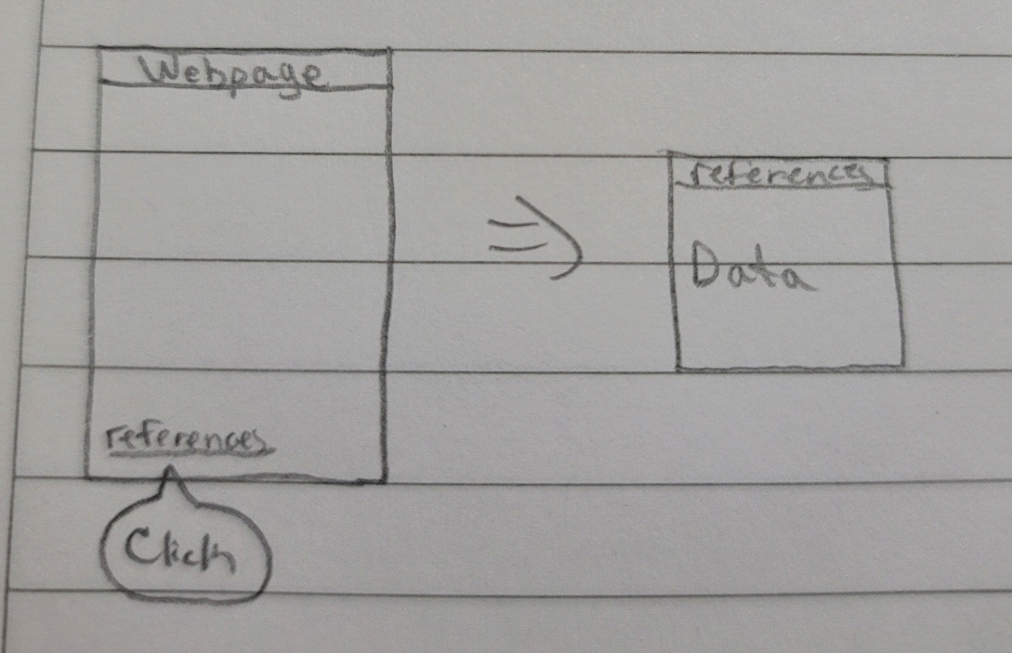

## User Story

* As a user I want to select specific age ranges on a graph to view data for that range.

## User Acceptance Test

* **Scenario:** I want to view data for a specific age range on a graph.

**Given:** I am on a graph that features age as a data point.

**When:** I go to the menu on the graph with the age range options.

**Then:** Click on a option.

## User Story Workflow

### Figure 37. Workflow of Graph Age Range Selection

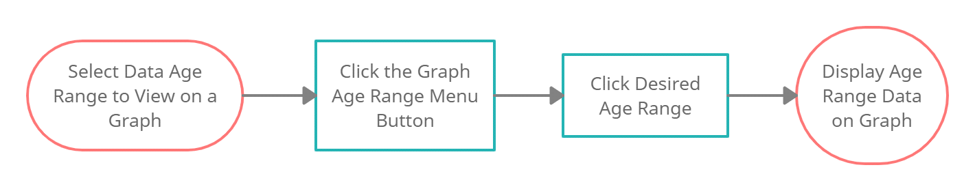

## Data Requirements

* A graph with the desired data that has age range options.
* A menu with the age options.

## Wireframe Template



### Figure 38. Wireframe of Graph Age Range Selection

## User Story

• As a user I want to search total cases for a time period so that I can review the data.

## User Acceptance Test

* **Scenario**: I want to view total cases for a given time period.

**Given**: I am on a graph that allows time period selection.

**When**: I go to the menu on the graph with the time period options.

**Then**: Click on a option.

1. User Story Workflow

### Figure 39. Workflow of Graph Time Period Selection



1. Data Requirements

* A graph with the desired data that has time selection options.
* A menu with the time options.

## Wireframe Template

### Figure 40. Wireframe of Graph Time Period Selection



# Maintainability/Evolvability

* To ensure the maintainability of the web app all the elements of the software requirements will be appropriately documented. Moreover, the code that is going to be used will be commented and documented in each step. The code will be very clear for reading and will evade redundance as possible.
* The web application will use the latest version of each component. For example, Node 15.7.0 and ES9 JavaScript. The use of the latest framework and software available will ensure that the application keeps up to date to emerging technologies for full functionality.

# Reliability

The website will make the following recurrent tasks in order to assure the reliability of the page.

* A functionality test, where all the modules of the program will be tested before hand, in a separate branch, until no fatal errors occur, if minor errors do occur, it will be worked with during the day in a separate branch.
* A maintenance breaks each Saturday to test the database, to test the API’s data, to attend user reports and see what issues there are and address those issues.
* A security test every two (2) Sundays to expose and correct any bugs or corruption in the main code or in the API’s data.

# Availability

The website will have the following methods for the best availability possible.

* This application will have one database provided by Firebase which will have the copy of the data receiving from the APIs.
* The database will be updated in a daily basis.
* If the data gets corrupted it will automatically load the previous data point that was not corrupted. It also can be performed manually by an employee.
* If the program needs to restart from the beginning it will maintain all the main modules and the functions.
* The website will be available 24/7.

# Usability

* The interface of the web application will be constructed using different buttons placed strategically to increase the user experience. This strategy will allow the user to familiarize with ease at the moment of navigation through the web page. Furthermore, there will be headings that clearly identify plots or information inside the page. Goals such as downloading a plot or viewing more detailed information of the plot will be easy to achieve by the user. The use of drop-down lists and menus will also contribute to a positive user experience in which there is no requirement for an instruction set. The effectiveness of the application will be based on developing a web page that prioritizes user experience and intuition.

# Scalability

* Mostly on the intangible side, the scalability of bringing access to a bigger database to better accommodate more data from the API. This would also open more doors to utilize more data form other APIs, making more graphics and charts available.
* Restructuring the synchronous functions and algorithmic parts to be asynchronous, which would lower the workload of the maintenance.
* An addition to offer a system of subscriptions and notifications, making more use of the incrementation in the database.

# Hosting Costs Per Year

* The estimated costs per year of hosting the data base and the web application are based on the selection of a monthly plan for hosting. The selection of the plan depends on the number of monthly users thus the database and the web service instance to be rented is bigger.
* The proposed service will be Amazon Web Services with a cost in a range of $300 to $700 dollars. For possible totals of $3,600 and $8, 400 USD.

# Portability

* The website’s portability will consist of the devices, operating systems and browsers that will support the webpage. The website will run on computers, cellphones, and tablets. It will be accessible from the operating systems iOS, Android and Microsoft through a website, the guaranteed ones are Edge, Google Chrome, Mozilla Firefox, and Safari.

## 